SOME FASCINATING SURVIVALS
Peter B. Paisley
Sydney, Australia

A month ago, I was rummaging among slides mentally assigned to the “probably unascribable” category. Several had the same diamond inscribed handwriting and partial papering: the first few I examined had seemed pretty uninteresting.
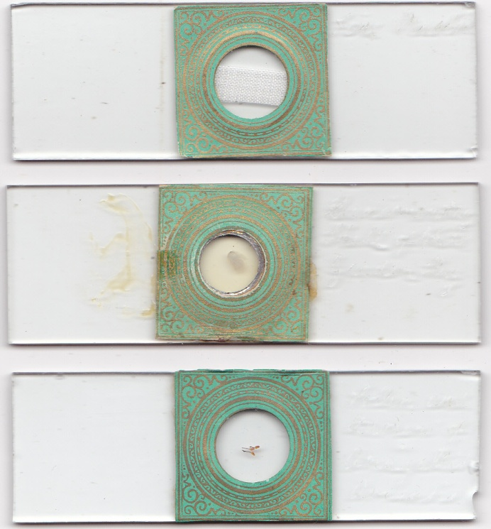
Top to bottom: fine muslin, rudimentary shell of white garden fly, and pollen and stamen of anagallis
They conform more or less to the 3x1 inch standard and are slightly irregular in size, indicating glass cut by the mounter: all have smoothed edges. Their only historical interest seemed the pattern and partial papering style, which I took to indicate earlyish nineteenth century work.
But a closer look at another slide, shown below, revealed startling subject matter.
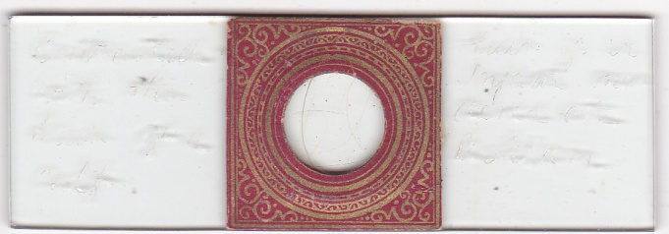
No different from the others in presentation: but – below - its diamond inscription is, to say the least, interesting.
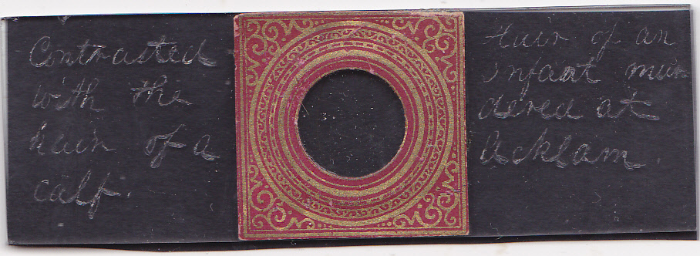
The hair of a murdered infant, contrasted with that of a calf, suggests that the mount may have been made as evidence, by someone with forensic authority. Alternatively, it could have been part of a forensic inventory, or used for teaching purposes. Another slide from the same batch, albeit lacking handwriting, reveals the probable identity of the mounter: more of that slide presently. A further infant hair slide is from the same lot, and may well also come from forensic work.
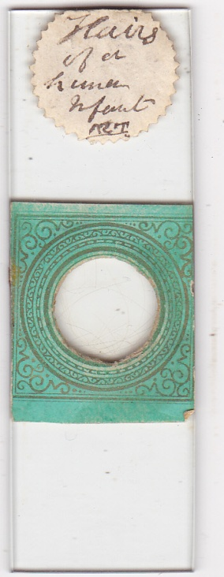
I have been unable to decipher the initials, which may be those of the infant (or the accused)
Arthur Farre
Arthur Farre (1811-1887) was a multi-talented medical and scientific luminary. Graduating in medicine in 1833, via Caius College Cambridge and St. Bartholomew’s Hospital London, he subsequently obtained a Cambridge MD. In between, he was elected a Fellow of the Royal Society for work on polypi, at the age of 29. In 1836, he was appointed Lecturer in Comparative Anatomy at St. Bartholomew’s; after two years, he lectured there for a further three years on forensic medicine, and contributed to the Cyclopaedia of Practical Medicine in this field.
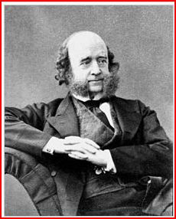
Arthur Farre
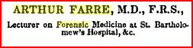
Farre’s entry in the Cyclopaedia
Not content with such wide achievements, he became Professor of Obstetrics at King’s College, remaining there from 1841 until 1862, and was elected Honorary President of the Obstetric Society of London in 1875. As a Fellow of the Royal College of Physicians, and obstetrician, he achieved great and highly fashionable success: he was Physician Extraordinary to Queen Victoria, and accoucheur to many members of the royal family, including the Princess of Wales.
When Baron Ferdinand de Rothschild suffered the premature loss of his wife Evelina and their baby son, he endowed the Evelina Hospital (long since demolished and replaced by a park) in 1869, and it was Arthur Farre who was chosen to design it.
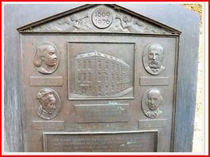
The present memorial plaque on the Evelina Hospital site: Farre’s relief portrait appears there, lower right
In 1849 he was involved in medical politics, contributing to the House of Commons’ Report to the General Board of Health on metropolitan workhouses. Later and more controversially he was again embroiled in politics. For many years an examiner at the Royal College of Surgeons, London, he resigned this post in protest at the proposal to admit medically unqualified women to their obstetric examinations. Farre was a founder member and later president of the Royal Microscopical Society, and author of many papers in their transactions.
Much more in detail could be told of Farre, but the foregoing should convey an idea of his achievements.
All the slides shown came from the same batch, with some others (below): the seller had no clue as to provenance, immediate or otherwise.
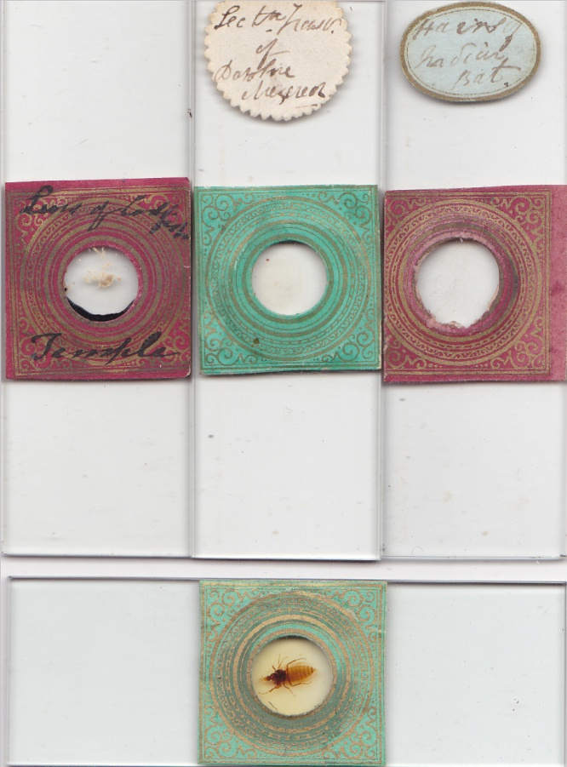
More slides from the same lot, with the same papering format
The identifying slide
Another slide carried a printed label (but no handwriting of any kind). Its label “microscopical transactions 1844” might have indicated an article in numerous publications from either side of the Atlantic. My first search however identified the article, and its author Arthur Farre. The paper in question – On the minute anatomy of the larva of Anthomyia, canicularis, Meigen, was presented to the Royal Microscopical Society in April 1841 and published in their transactions (vol.1) in 1844. It was based on a specimen retrieved in June 1837 from stomach contents of a girl who attended St. Bartholomew’s outpatient department. Not long later, Farre retrieved more specimens of the same species from another patient, presenting his results again to the RMS: he dissected them and his drawings, as illustrated below, also appeared in volume 1 of the RMS transactions.
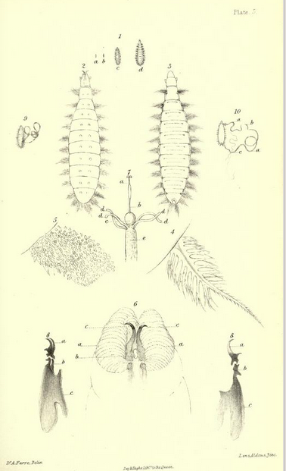
Farre’s specimens, drawn by himself
The slide below is from his findings, and may well feature the specimen on which his first communication on anthomyia was based. It was certainly gathered in 1837, as details in his papers show. Unlike some others I have shown it is mounted vertically, and markedly more formal in presentation. Its half papered style however, and the fact that all the slides were in the same batch, seem to indicate the same maker.
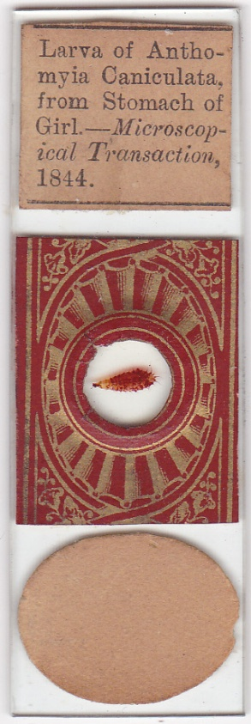
To find a specimen from 1837 in near mint condition is rare enough, and to find one so precisely documented is even rarer. The fact that Farre was an expert forensic consultant strengthens evidence for him as the probable maker of the infant hair slides. I have been unable to trace specific details on the case of the murdered infant – perhaps readers with expertise in searching English legal records can supply the reference.
There were two cases of infant murders at Acklam in 1856, reported in the Yorkshire Gazette in March of that year: my searches revealed no references to Farre in connection with these, but his opinion may have been sought by those involved locally with the resulting court cases.
Conclusion
The last slide shown above seems sure to have been made by Farre, and it is probable that the others were too. If there is a moral in this tale for collectors, it must be to take an occasional closer look at their miscellania. Sometimes that can lead to unexpectedly interesting results.
Acknowledgement
Thanks to David Walker for drawing my attention to the newspaper archive
Sources
Wikipaedia
www.archive.org
google books
“Munk’s Roll”: in the Royal College of Physicians (London) web site
www.britishnewspaperarchive.co.uk

Author contact: lois737@bigpond.com
Published in the November 2012 issue of Micscape Magazine.
www.micscape.org

