The desmid Micrasterias rotata
by Stephen Durr, UK

This flat discoid alga belongs to the Desmid family, which encompass over 6000 species worldwide and which are only found in freshwater habitats, usually confined to acidic rocks and soft water. Desmids have long been a favourite of microscopists because of their exquisite beauty. Desmids can be found in large amounts by pulling out a handful of sphagnum moss and squeezing the excess water into a jar, when the water has settled take a pipette and place a drop of the water under the microscope and scan with a low power. Desmids belong to the very large group of algae called Chlorophytes and are always green in colour.
This species shown here is called Micrasterias and is fairly common around Northern Europe. It can measure up to 350 µm in length and can therefore just be seen with the naked eye. It can be seen from the photograph that these cells consist of two symmetrical semi circular halves, which are separated by a narrow waist called the isthmus, many desmids are built along this body plan but shapes may vary widely. The nucleus can be seen in the middle of the isthmus, which is the thin stripe that joins the two semi cells together. The thallus is studded with large numbers of pryenoids that act as storage organelles and also produce starch.

This photograph was taken with Leitz X25 Nomarski objective mounted on an Orthoplan research microscope; which gives the single celled organism its 3D effect.
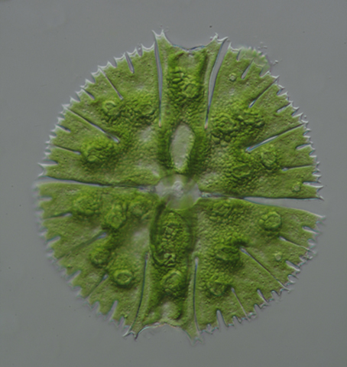

This image was taken with a Nikon Diaphot inverted UV microscope. The red colouration is caused by the algal cell absorbing the short wavelength light and re emitting at a longer wavelength. This type of luminescence is called fluorescence. A high pressure mercury lamp was used with various exciting barrier filters and when used with a dichromatic mirror that reflects 90% of the short wavelength, allowing the longer wavelengths to pass unhindered. The light emitted by the lamp is 360nm, which is invisible to the human eye. This short wavelength excites some of the electrons within the molecules causing them to vibrate rapidly and jump to a higher energy level. The electrons prefer a less energetic state and re radiate a photon at a longer wavelength which can be seen as a red image. Using the correct objectives is important when using ultra violet light.

Mercury arc lamps can be dangerous so should not be used by an inexperienced person; there is a danger of explosion and of course poisonous fumes.

All images by Stephen Durr.

Comments to the author welcomed, email steveoid AT outlook DOT com

Published in the May 2015 issue of Micscape Magazine
www.micscape.org

