MY MICSCAPE EXPERIENCE
Alejandro Ariel García Arriaga Coacalco de Berriozábal, Estado de México, Mexico

I found MICSCAPE while learning about microscopy on the internet. I had just received my microscope a few days ago, and I was trying to understand how brightfield and darkfield illumination works, then I found the page that I show in the screen below and it was this page that took me to MICSCAPE because as you can see in the picture there is a reference under the figure in small letters and it's the article of Wim van Egmond “Easy to make' contrast enhancement filters for the microscope dark-field, oblique and Rheinberg illumination”

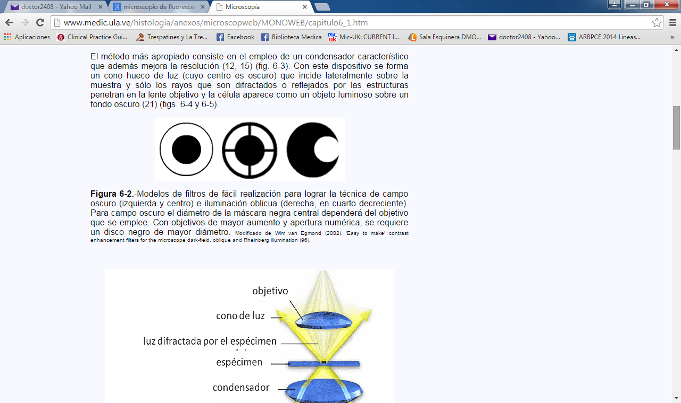
I copied it and pasted it in Google searcher and as you can see it took me directly to Micscape.
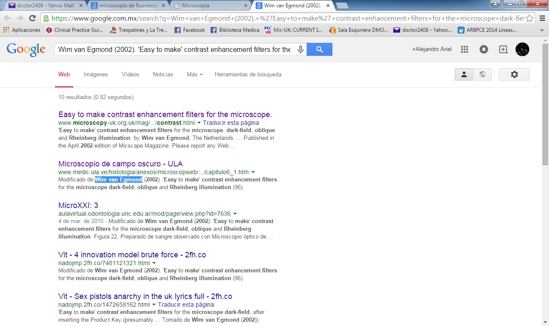

I opened the article,
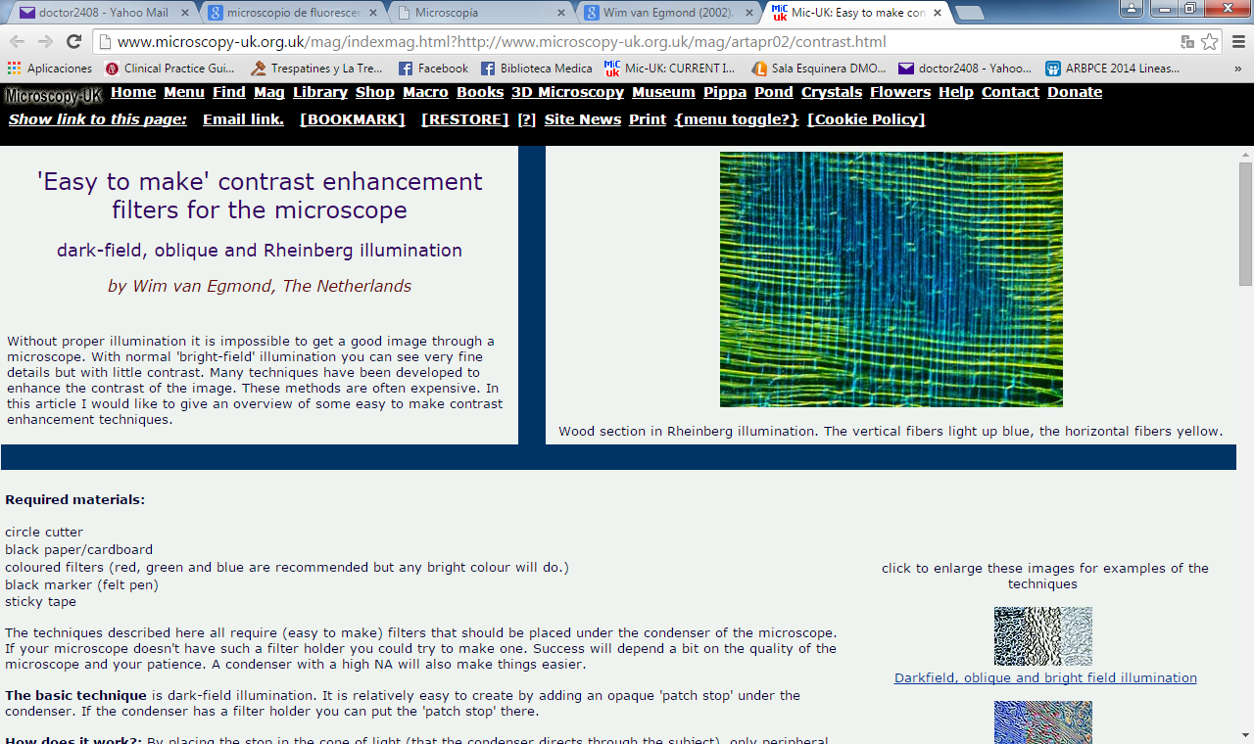
read the content and that same afternoon I met MICSCAPE.

Since I was interested in the topic of Rheinberg illumination I wrote in the searcher RHEINBERG FILTERS and took me once more to MICSCAPE.
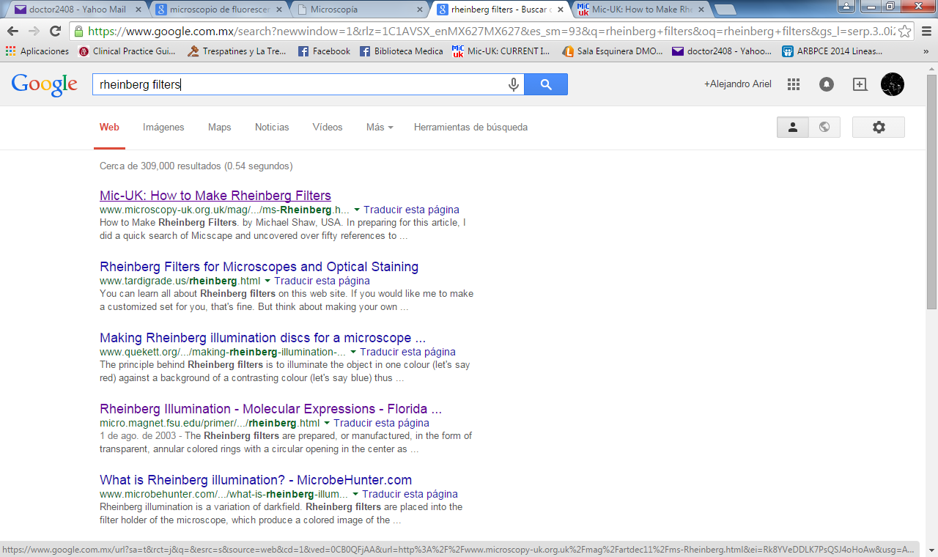
Again I opened the article and I found “How to Make Rheinberg Filters” by Michael Shaw.
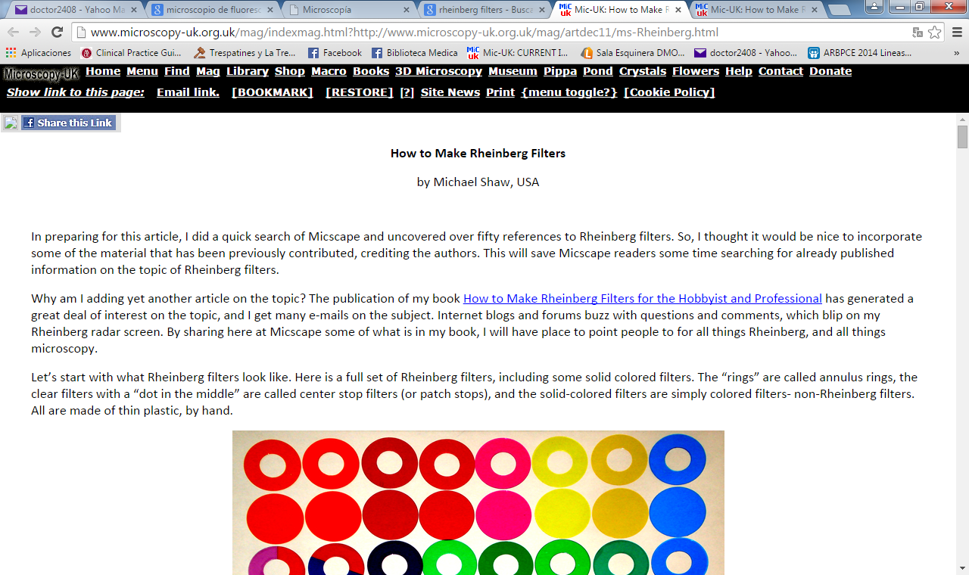

But now I also entered the link HOME and at this moment I met MICROSCOPY–UK.
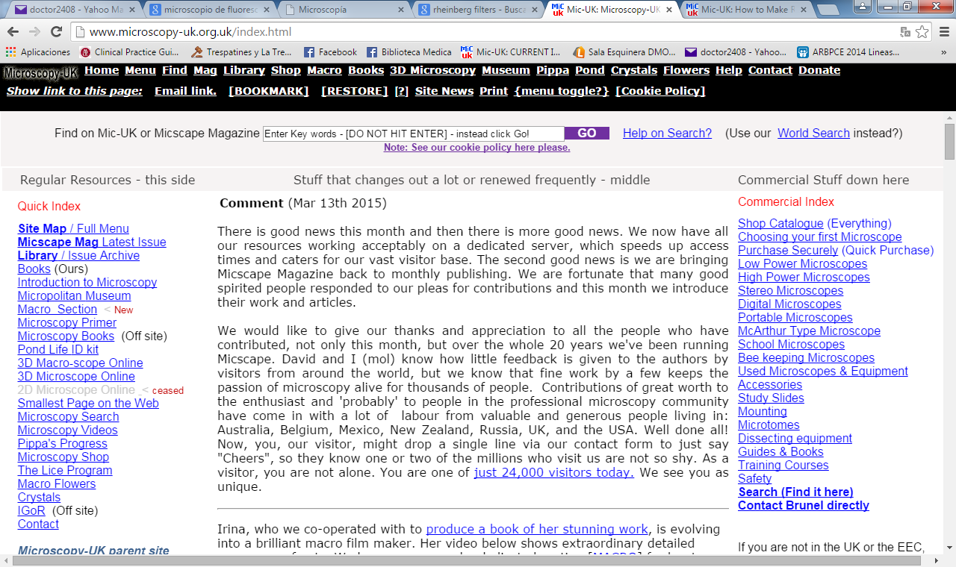
Obviously the page I show in the picture above is not the first that I found some months ago because this is the current one, I started to explore all the LINKS, so I opened the Library:
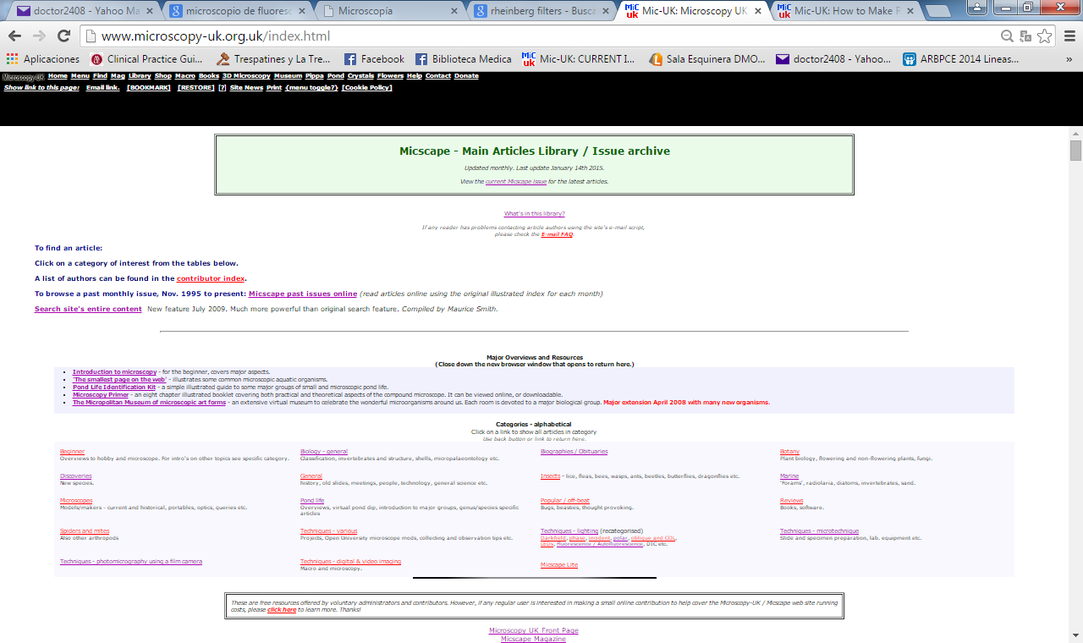
I became interested in the icon 'Techniques - lighting (recategorised)'

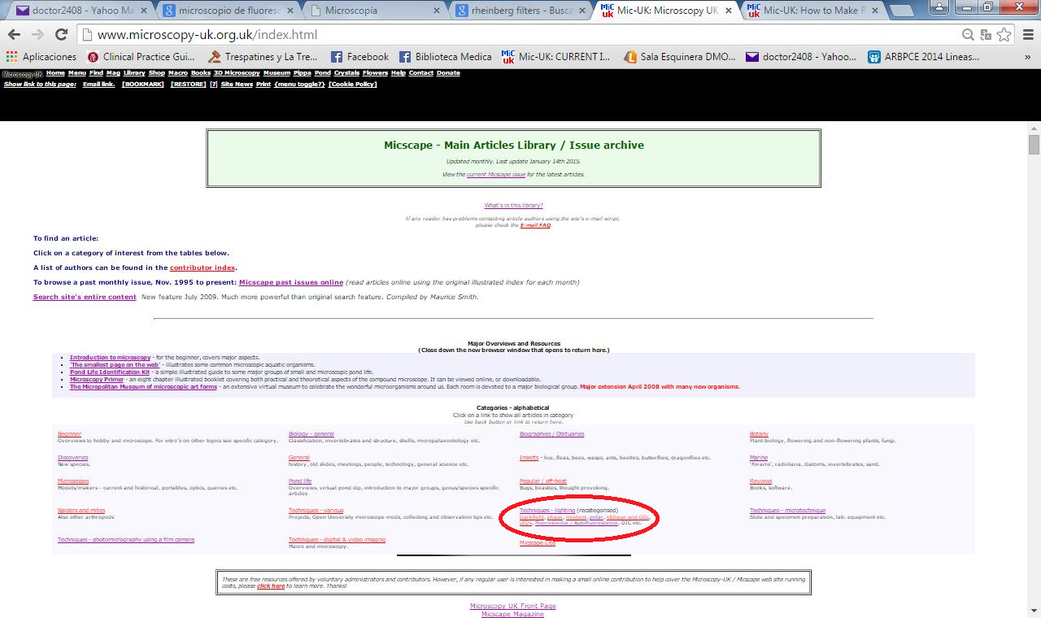
and during the next several months I was studying the articles principally for oblique illumination and darkfield illumination.

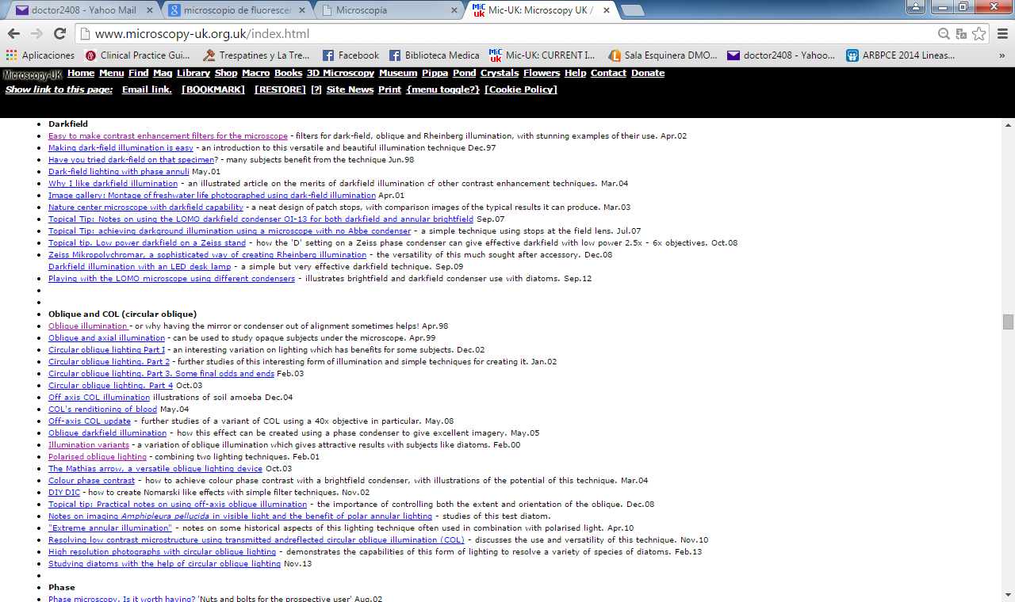
I tried the ones that were possible for me to do like Rheinberg filters, oblique illumination, with this exploration I came across the article “DIY-DIC” of Wim van Egmond that was the inspiration for mine “DIY-DIC SEVERAL COLORS” that was published on March 13, 2015. I have also tried Rheinberg filters, Mathias arrow exposé by Walter Dioni who was Mexican too and circular oblique illumination exposed by Paul James.
I have explored almost all the library and the content of MICROSCOPY –UK and I have found tons of inspiring articles by people like me around the world who like explore the micro world.
I can say now that the majority of the things that I know about microscopy I have learnt them via MICROSCOPY –UK and MICSCAPE.
I had not had the chance to record my observations and it was not until the beginning of this year that I could, so as I have seen in the library that it was possible to send contributions to the magazine.
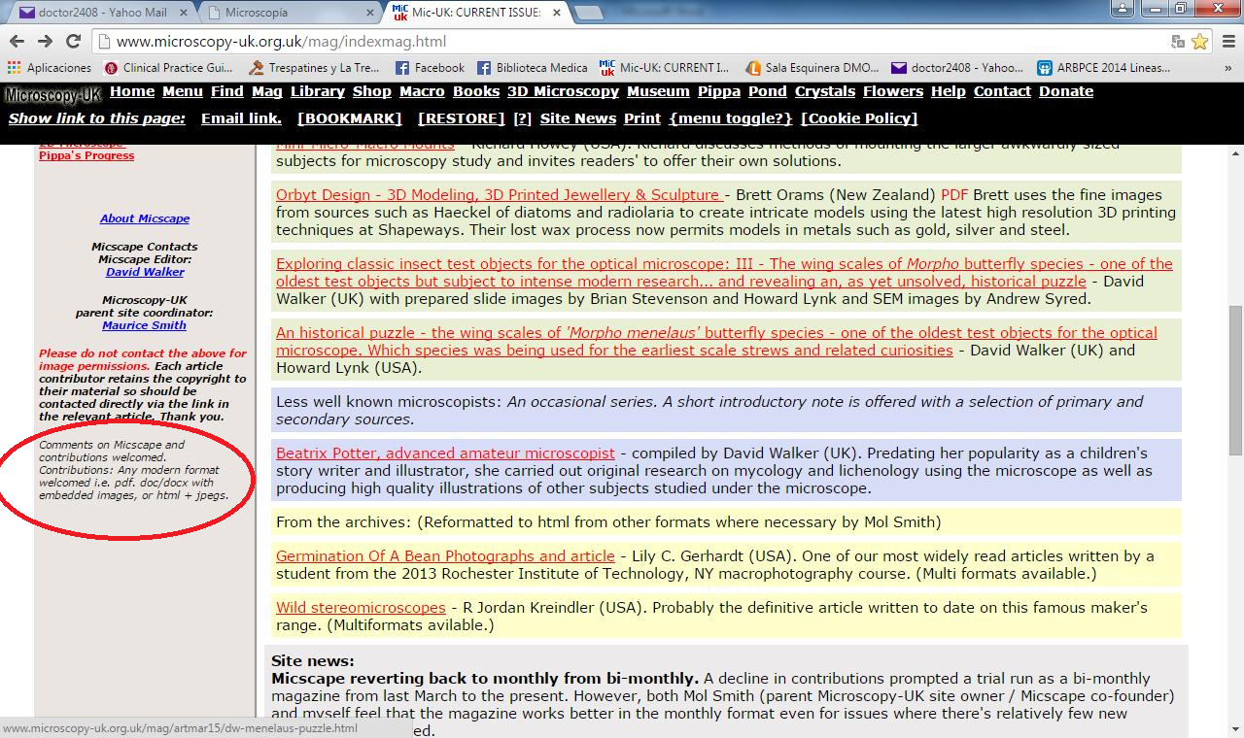

And while exploring I have seen too a form of contacting the magazine:
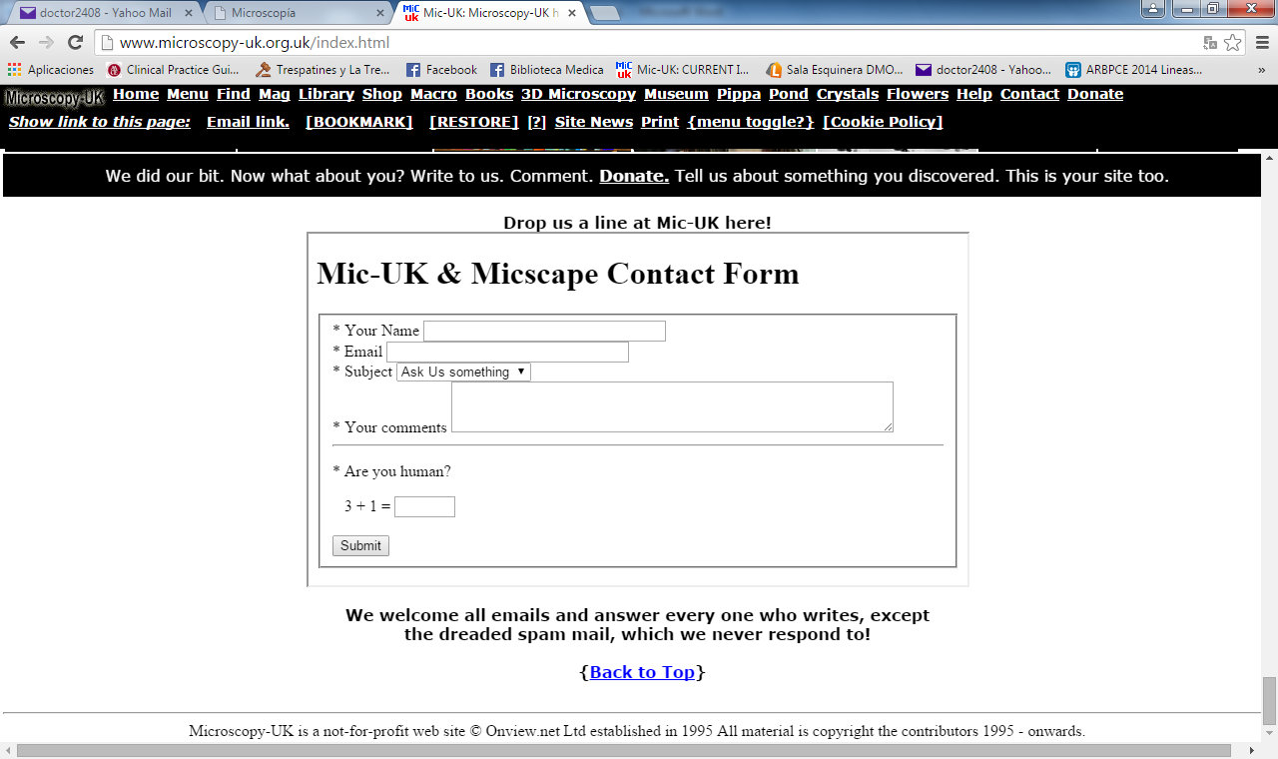
I submitted the information required and told them that I was interested in contributing with some observations that I was doing with my microscope and a camera that I had. The following day I received an answer in my e- mail box from Maurice Smith, Microscopy-UK parent site coordinator who welcomed me with the words on the screen.

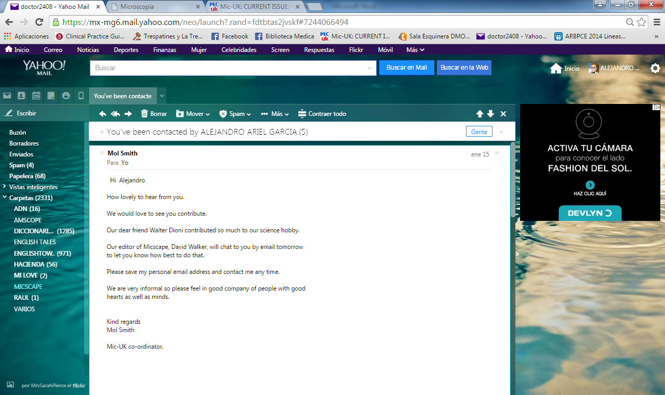
As promised David Walker chatted to me the following day.

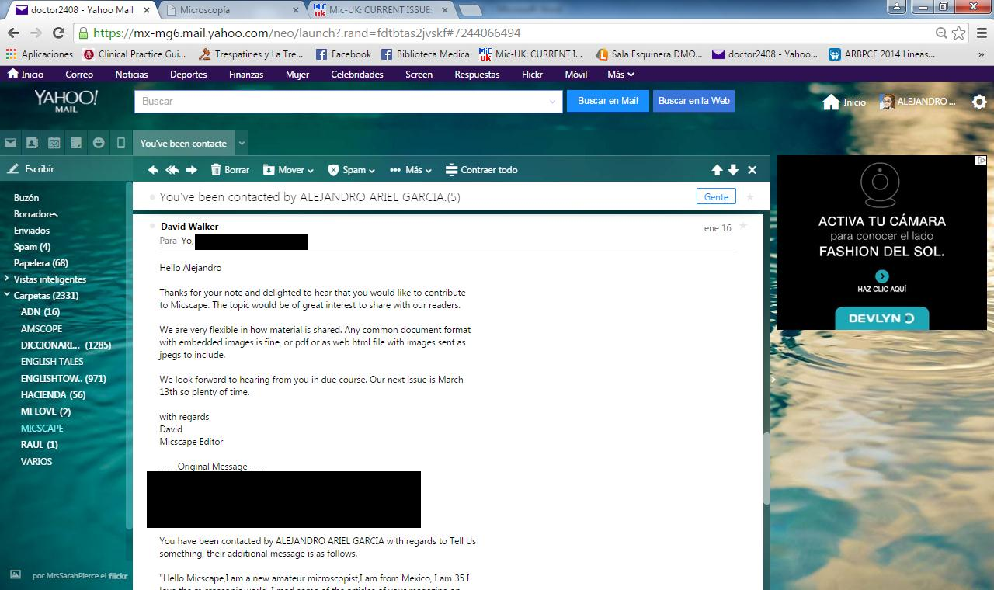
And this way I was accepted as a contributor to MISCAPE and I met at least by e-mail these two great men that with their projects they are reaching the most distant places in the world.

WHAT MICSCAPE DOES TO PEOPLE THAT READ IT?
They give a “window” to show the observations, so that they can be known by the entire world.
They elicit and enhance creativity in two ways first by telling you on the page: “We are delighted to receive contributions small or large from microscopy enthusiasts whether a novice or expert. If you have an image, tip or article, why not share it, this magazine is what you make it!”
Then when you are accepted to contribute and published your creativity starts to flow because you are thinking what other of the observations that you have made or are making can be sent to be shared the next month, at least this is what happens to me - ideas for contributions come to mind thanks to this opportunity.
It is true that when you like this hobby of observing with your microscope it is a personal passion that published or not you would happily do, but this gives people a more profound sense to this because our observations are not just a cumulus of files in our computers, instead they become a mass of information that enters the communication pathway because now they have receptors.

They put you in contact with people around the world because you can contact the contributors and discuss the topics published so it functions like a forum.
They give you opportunity to widen your knowledge by introducing you to some other sites external to them that you can also explore in order to learn.
They simply inspire you when you read the articles, for example in my case when I saw the 3D pictures I started to look for means to create my own 3D pictures and believe me the inspiration has allowed me to get nice results.

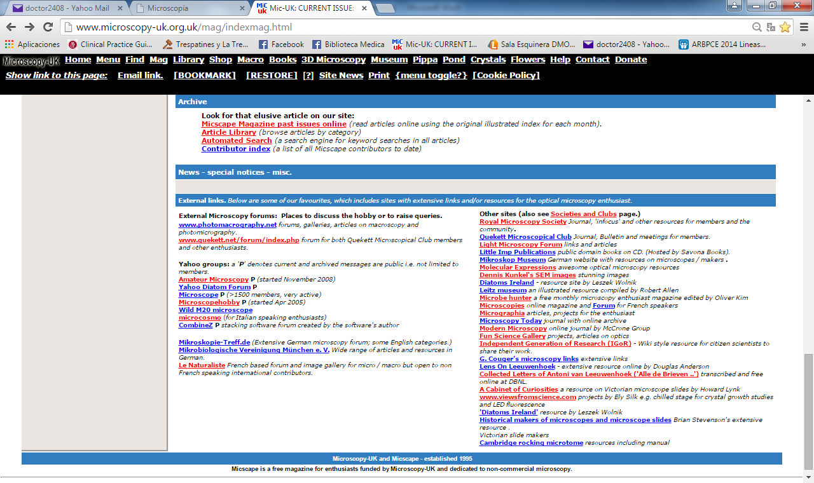

The benefits mentioned above and some others that you by yourself can discover are the things that MICSCAPE can do for you and that has done for me and surely for many people around the world in these first twenty years.
Do you want some inspiration for eliciting you microscope hobby? Read please this article: “Inspiration and the Microverse” - Mol Smith (UK) here is the link.

Please read this marvelous article of Mol Smith in the bimonthly issue January- February of this 2015.
CONCLUSION:
Thanks a lot Micscape and MICROSCOPY-UK for your contributions to my knowledge.
THANK YOU MOL AND DAVID
Though it was on November 1995 that the first issue was published and it wont be until November this year for the twentieth anniversary I would like to go ahead and tell you
CONGRATULATIONS FOR THE 20TH year OF MICSCAPE

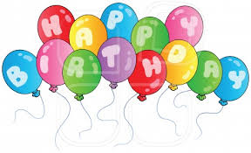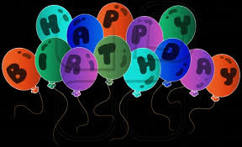
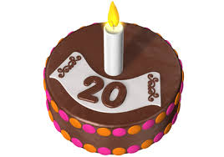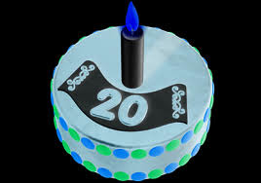

Email author: doctor2408 AT yahoo DOT com DOT mx
(Above in anti-spam format. Copy string to email software, remove spaces and manually insert the capitalised characters.)

Published in the May 2015 issue of Micscape Magazine.
www.micscape.org

